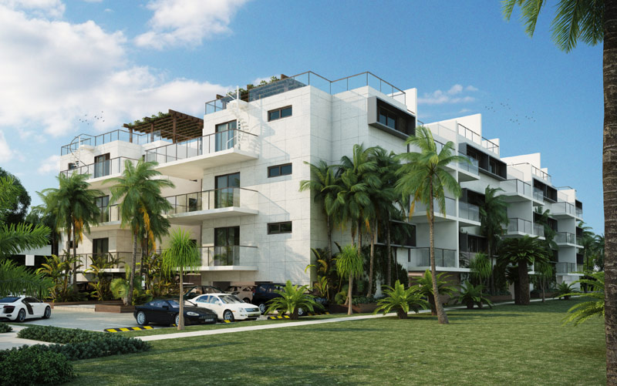

welcome to Suite 203 |THIRTY-SIX, Paradise Island Nassau The Bahamas

A sophisticated and modern private residence with sweeping views. Suite 203 is a newly constructed, fully furnished and fully equipped 1,400 sq. ft. two-bedroom, two-bathroom ultra-luxury condominium suite at Thirty-Six.
THIRTY-SIX is an intimate 36 suite condominium residence. Exquisitely designed and meticulously constructed by a team of leading international architects, builders and interior designers. Located on Bayview Drive - a quiet, well-groomed residential enclave, adjacent to Ocean Club Estates on Paradise Island, The Bahamas.

Suite 203 | THIRTY-SIX is a wonderfully serene, private and ultra-luxurious getaway with immediate access to an unsurpassed array of internationally renowned restaurants, nightlife and unbelievable amenities

Suite 203 Amenities
- Concierge services.
- Private, gated entrance with 24-hour security.
- Steps from Atlantis.
- Steps from Ocean Club Four Seasons Resort.
- Steps from Ocean Club Golf Course.
- Steps from Paradise Island Beach.
- Close to Sivananda Yoga Retreat.
- Close to Nassau.
- Close to Bahamas Ferries for excursions to the other islands.
- Close to marinas for boat charters - sport fishing, snorkel/scuba diving.
- Close to hospitals - Princess Margaret and Doctor's Hospital.
- Close to pharmacy.
- Close to groceries and supplies - Solomon's Fresh Market, 700 Wine & Spirits.
- Housekeeping, Private Chef, RMA and other services available.
- Luxurious, coastal-modern interior with designer furniture.
- Professional-grade kitchen with Sub Zero and Wolf appliances.
- Reverse osmosis water filtration system that eliminates the need for bottled water.
- Full laundry room with full-size clothes washer, dryer, ironing board and iron.
- Free Wi-Fi and individually controlled air conditioning.
- Electric generator that automatically powers everything in the event of a power failure.
- Nine-and-a-half-foot ceiling with hurricane rated, impact resistant windows and doors.
- Living room with 65” Samsung TV, Bang & Olufsen BT Stereo and ceiling fan.
- Master bedroom with king size bed, luxury ensuite bathroom and walk-in closet.
- Master bedroom with 43” Samsung TV, ceiling fan and BT clock radio.
- Guest bedroom with queen size bed, luxury ensuite bathroom, ceiling fan and closet.
- Private covered terrace, luxuriously appointed with Cane-Line and Dedon furniture & ceiling fan.
- Beautifully landscaped grounds.
- 65 ft. Infinity Pool overlooking Nassau Harbour with indoor and outdoor lounge.
- State of the art gym.
- Dedicated parking space.
RATES

SEASON | DATE RANGE | STANDARD RATE | PREFERRED RATE
 |  | US$ | 14+ NIGHTS | 7+ NIGHTS | 4+ NIGHTS
1 | 5 January – 30 March | 675 | -15% | -10% | -5%
2 | 31 March – 30 April | 750 | -15% | -10% | -5%
3 | 1 May – 30 June | 675 | -15% | -10% | -5%
4 | 1 July – 31 October | 525 | -15% | -10% | -5%
5 | 1 November – 21 November | 675 | -15% | -10% | -5%
6 | 22 November – 30 November | 850 | -15% | -10% | -5%
7 | 1 December – 20 December | 675 | -15% | -10% | -5%
8 | 21 December – 4 January | 950 | -15% | -10% | -5%

All rates are quoted and transacted in US Dollars.
Rates include booking service fees and credit card transaction fees.
Standard Rates and Preferred Rates are subject to change without notice.
There is a minimum stay of three nights.
Maximum accommodation is 4 guests.
Minimum age of the Primary Guest is 25 years
A deposit of 50% of the total rate is charged at the time of booking.
The balance of the total rate will be applied to the same credit card 14 days prior to your arrival date
No refund if cancelled within 14 days of your arrival date.
Check-in is at 3 pm.
Check-out is at 12 Noon.
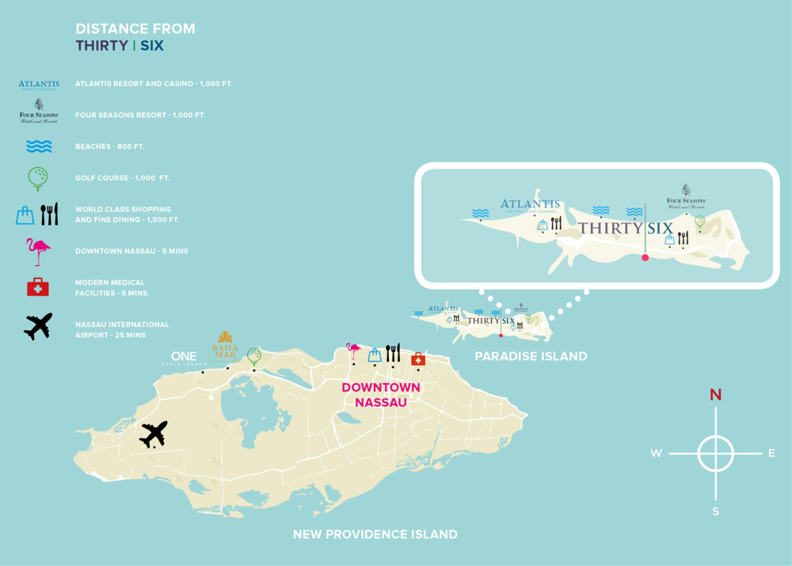

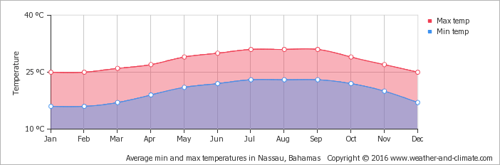

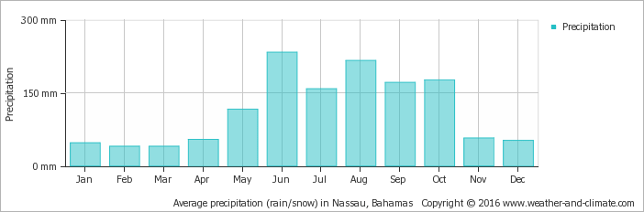

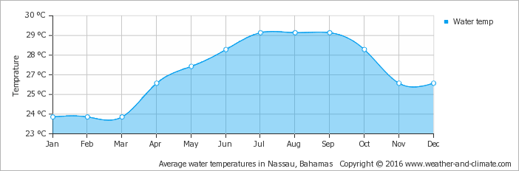
ESSENTIAL INFO
Concierge Services: 242 325 4465
Security Desk: 242 677 5186
Wifi password: beautiful
Parking Space: #39
David & Cynthia Mitchell: 416 347 2926

Transport

Air: Lynden Pindling International Airport: 242 702 1010
Bahamas Air: 242 702 4140
Water: Bahamas Ferries: 242 323 2166

Emergency Services
Police Emergency: 911
Police Non-Emergency: 242 322 4444
Fire: 919
Doctors Hospital Ambulance Services: 242 302 4747
Princess Margaret Hospital Accident and Emergency: 242 326 7014
24 Hour Pharmacy: 242 325 6127

Canadian Consulate
On Paradise Island: 242 393 2123 / 4

Banks
Scotiabank: 242 393 7103
Royal Bank: 242 356 8500

Postal Services & Shipping
General Post Office: 242 322 4917
FedEx: 242 322 5656
UPS: 242 323 0003 / 0008

Groceries & Supplies
Solomon’s Fresh Market: 242 677 7290
700 Wines & Spirits, Harbour Bay: 242 394 0370
24 Hour Pharmacy: The Prescription Parlour, 242 356 3973

